Department of Computer Technology

Vision of the Department
To be a preferred hub for nurturing computer engineering aspirants through innovative, ethical, value-based technical education, impactful research, and industry collaboration, to become successful professionals contributing for the betterment of society.

Mission of the Department
To nurture computer engineering professionals by offering: Dynamic learning environment that encourages problem-solving using emerging technology, · National Education Policy aligned evidence-based technical education, fostering innovation, research, and industry–institute
collaboration, Holistic, ethical and sustainable development for lifelong success.

Session 2026-2027(ODD)

Vision: Dream of where you want. | Mission: Means to achieve Vision

Program Educational Objectives of the program (PEO): (broad statements that describe the professional and career accomplishments)
PEO1 | Preparation | P: Preparation | Pep-CL abbreviation
PEO2 | Core Competence | E: Environment (Learning Environment) | pronounce as Pep-si-lL easy to recall
PEO3 | Breadth | P: Professionalism
PEO4 | Professionalism | C: Core Competence
PEO5 | Learning  Environment | L: Breadth (Learning in diverse areas)

Program Outcomes (PO): (statements that describe what a student should be able to do and know by the end of a program)

Keywords of POs:
Engineering knowledge, Problem analysis, Design/development of solutions, Conduct Investigations of Complex Problems, Engineering Tool Usage, The Engineer and The World, Ethics, Individual and Collaborative Team work, Communication, Project Management and Finance, Life-Long Learning

PSO Keywords: Cutting edge technologies, Research

“I am an engineer, and I know how to apply engineering knowledge to investigate, analyse and design solutions to complex problems using tools for entire world following all ethics in a collaborative way with proper management skills throughout my life.” to contribute to the development of cutting-edge technologies and Research.

Integrity: I will adhere to the Laboratory Code of Conduct and ethics in its entirety.

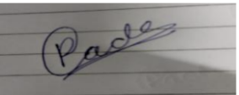
Poonam Gade / 22-08-2026

Name and Signature of Student and Date
(Signature and Date in Handwritten)

Department of Computer Technology

Vision of the Department
To be a preferred hub for nurturing computer engineering aspirants through innovative, ethical, value-based technical education, impactful research, and industry collaboration, to become successful professionals contributing for the betterment of society.

Mission of the Department
To nurture computer engineering professionals by offering: Dynamic learning environment that encourages problem-solving using emerging technology, · National Education Policy aligned evidence-based technical education, fostering innovation, research, and industry–institute
collaboration, Holistic, ethical and sustainable development for lifelong success.

Session | 2026-27 (ODD) | Course Name | LAB: Software Engineering
Semester | 7th | Course Code | 23CT1704
Roll No | 12 | Name of Student | Poonam Gade

Practical Number | 5
Course Outcome | Upon successful completion of the course the  students will be able to;  1. Choose appropriate software engineering  process model, requirement engineering  principles and software designing  fundamentals for a given project.  2. Select appropriate testing strategy and apply  testing principles for testing a given  application.  3. Apply basics of software configuration  management, version control and change  control in software development.  4. Evaluate cost estimation, effort and severity  of software risk for given application.  5. Perform basic operations on Sub-version for  software version control.
Aim | To study and draw UML Class Diagram for the Online Voting System.
Problem Definition | An Online Voting System is a software system that allows voters to register, log in, participate in an election, view candidate details, and cast their votes. The Election Administrator manages elections, voters, and voting activities. The system records and verifies votes, generates election results, and maintains complaints and audit logs for proper monitoring and transparency.
Theory  (100 words) | A UML Class Diagram shows the structure of a software system. It represents classes, attributes, methods, and relationships between classes.  What is class?  A class is a blueprint of an object. For example, Voter is a class with attributes such as voterId, name, and email, and methods like register(), login(), and castVote().  Main Elements  - Class Name – Name of the class.  - Attributes – Data or properties of the class.  - Methods – Functions performed by the class.  - + Public, - Private, # Protected.  Relationships  - Association – Normal connection between classes.  - Aggregation – Shows a part-of relationship.  - Composition – Strong part-of relationship.  - Dependency – One class uses another class.  - Inheritance – One class inherits another class.  In the Online Voting System, the main classes are Voter, Election, Candidate, Vote, Election Administrator, Complaint, Result, AuditLog, and Auditor.
Procedure and Execution  (100 Words) | Algorithm(Steps):  - Start.  - Identify the classes of the Online Voting System.  - Identify the attributes of each class.  - Identify the methods of each class.  - Identify the relationships between the classes.  - Draw the classes in StarUML.  - Connect the classes using appropriate relationships.  - Check the class diagram.  - Save the UML Class Diagram.  - Stop.
Output:
The UML Class Diagram for the Online Voting System was successfully designed using StarUML.
The diagram shows the interaction between the Voter, Election Administrator, and the functions provided by the Online Voting System.
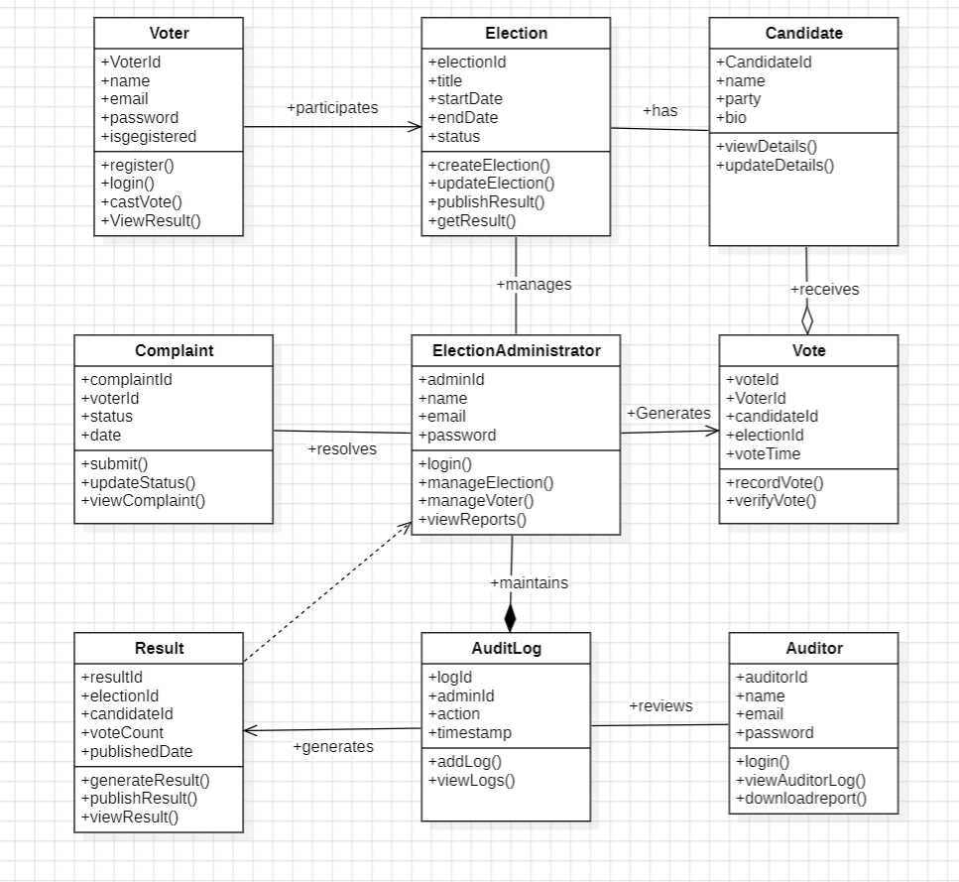

Output Analysis | The Class Diagram shows the main classes of the Online Voting System such as Voter, Administrator, Candidate, Election, Vote, and Result. It also shows their attributes, methods, and relationships.
Link of student Github profile where lab assignment has been upload | https://github.com/23070177-cmyk
Conclusion | The UML Class Diagram for the Online Voting System was successfully studied and designed. It gives a clear understanding of the classes and their relationships in the system.
Plag Report (Similarity index < 12%) | 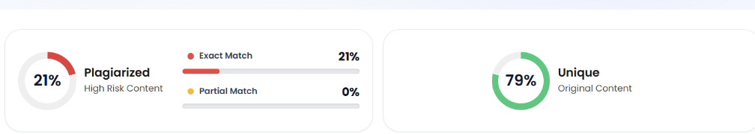
Date | 22-08-2026

